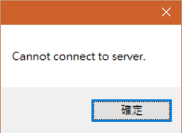

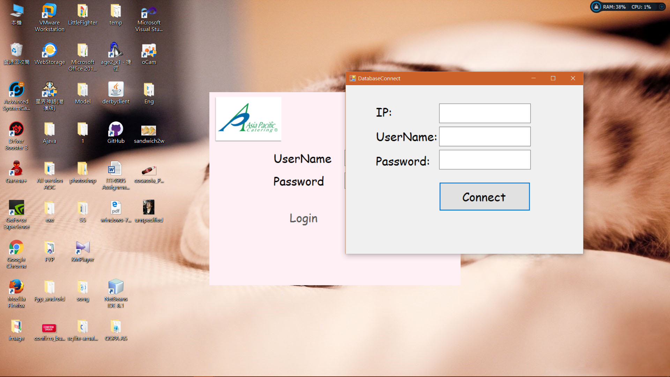

LOCK

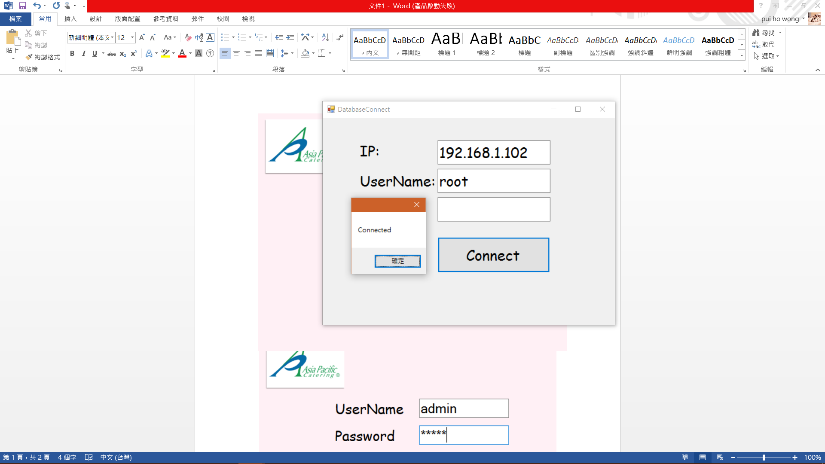

Login fail or successful

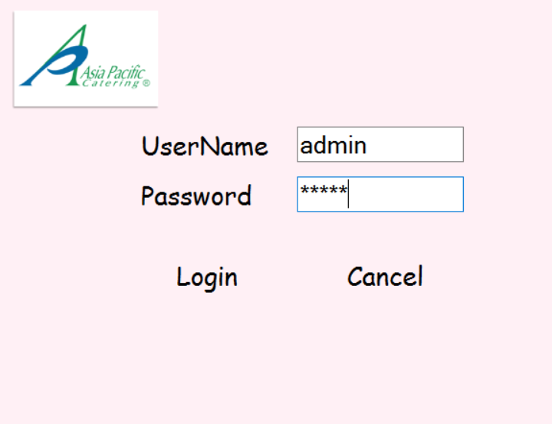

UserName: admin Password: admin

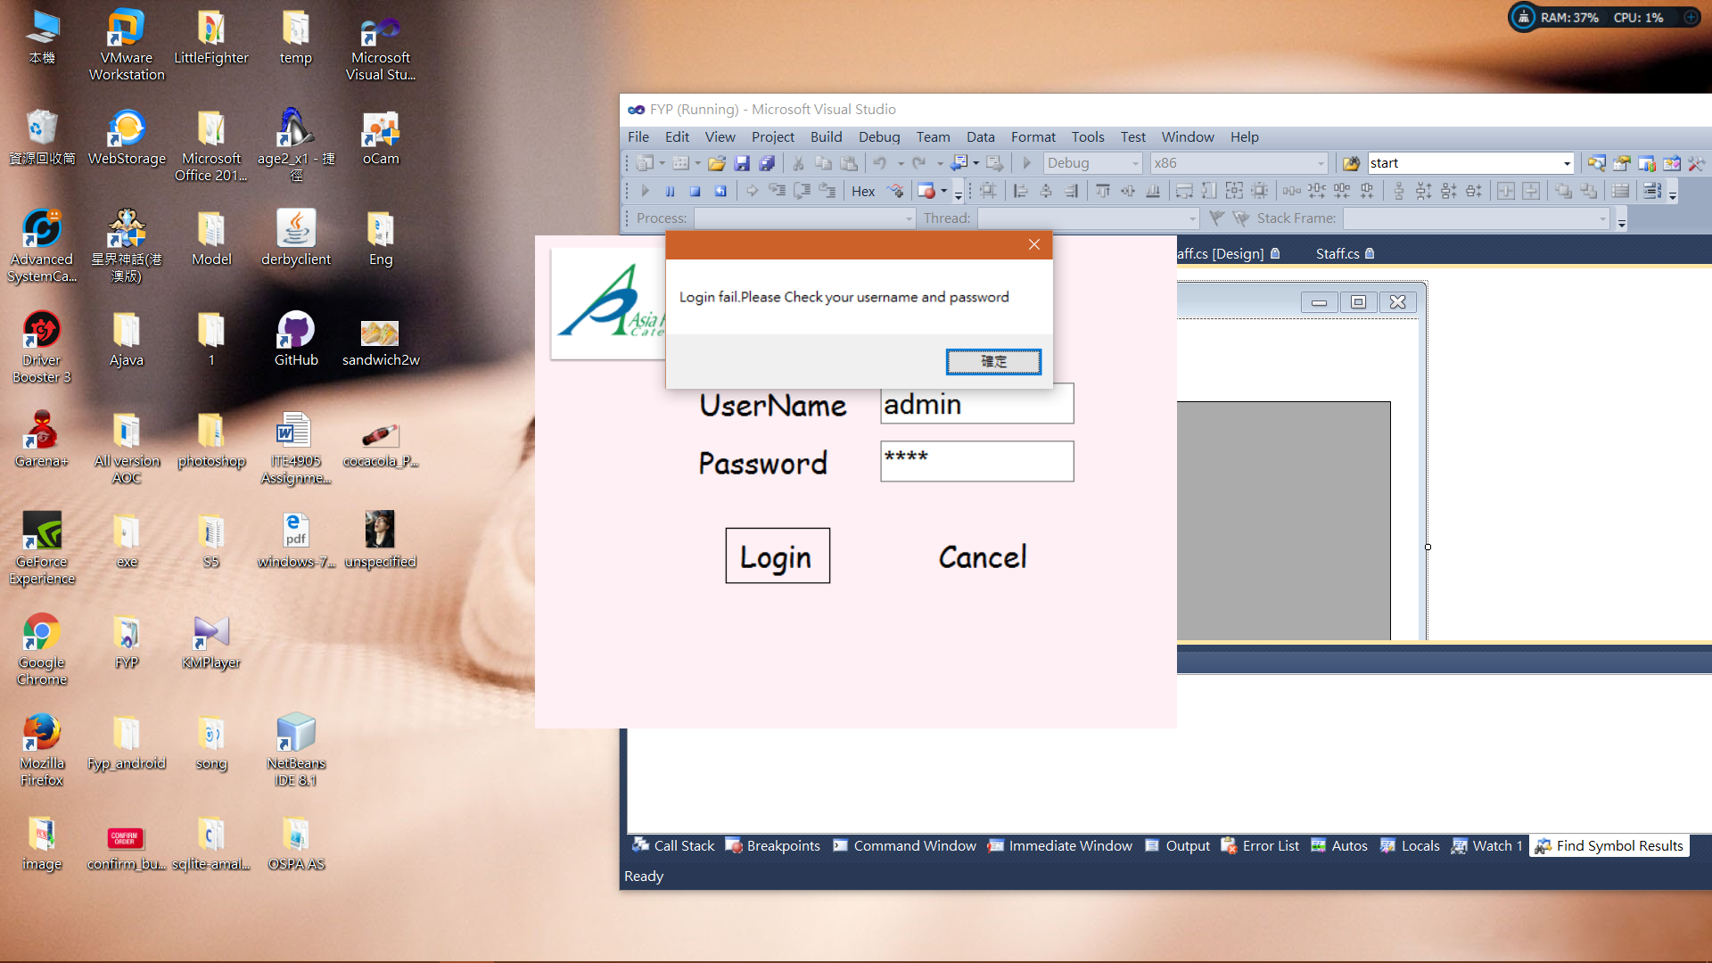

UserName: admin Password: admi

Set Ordering System time

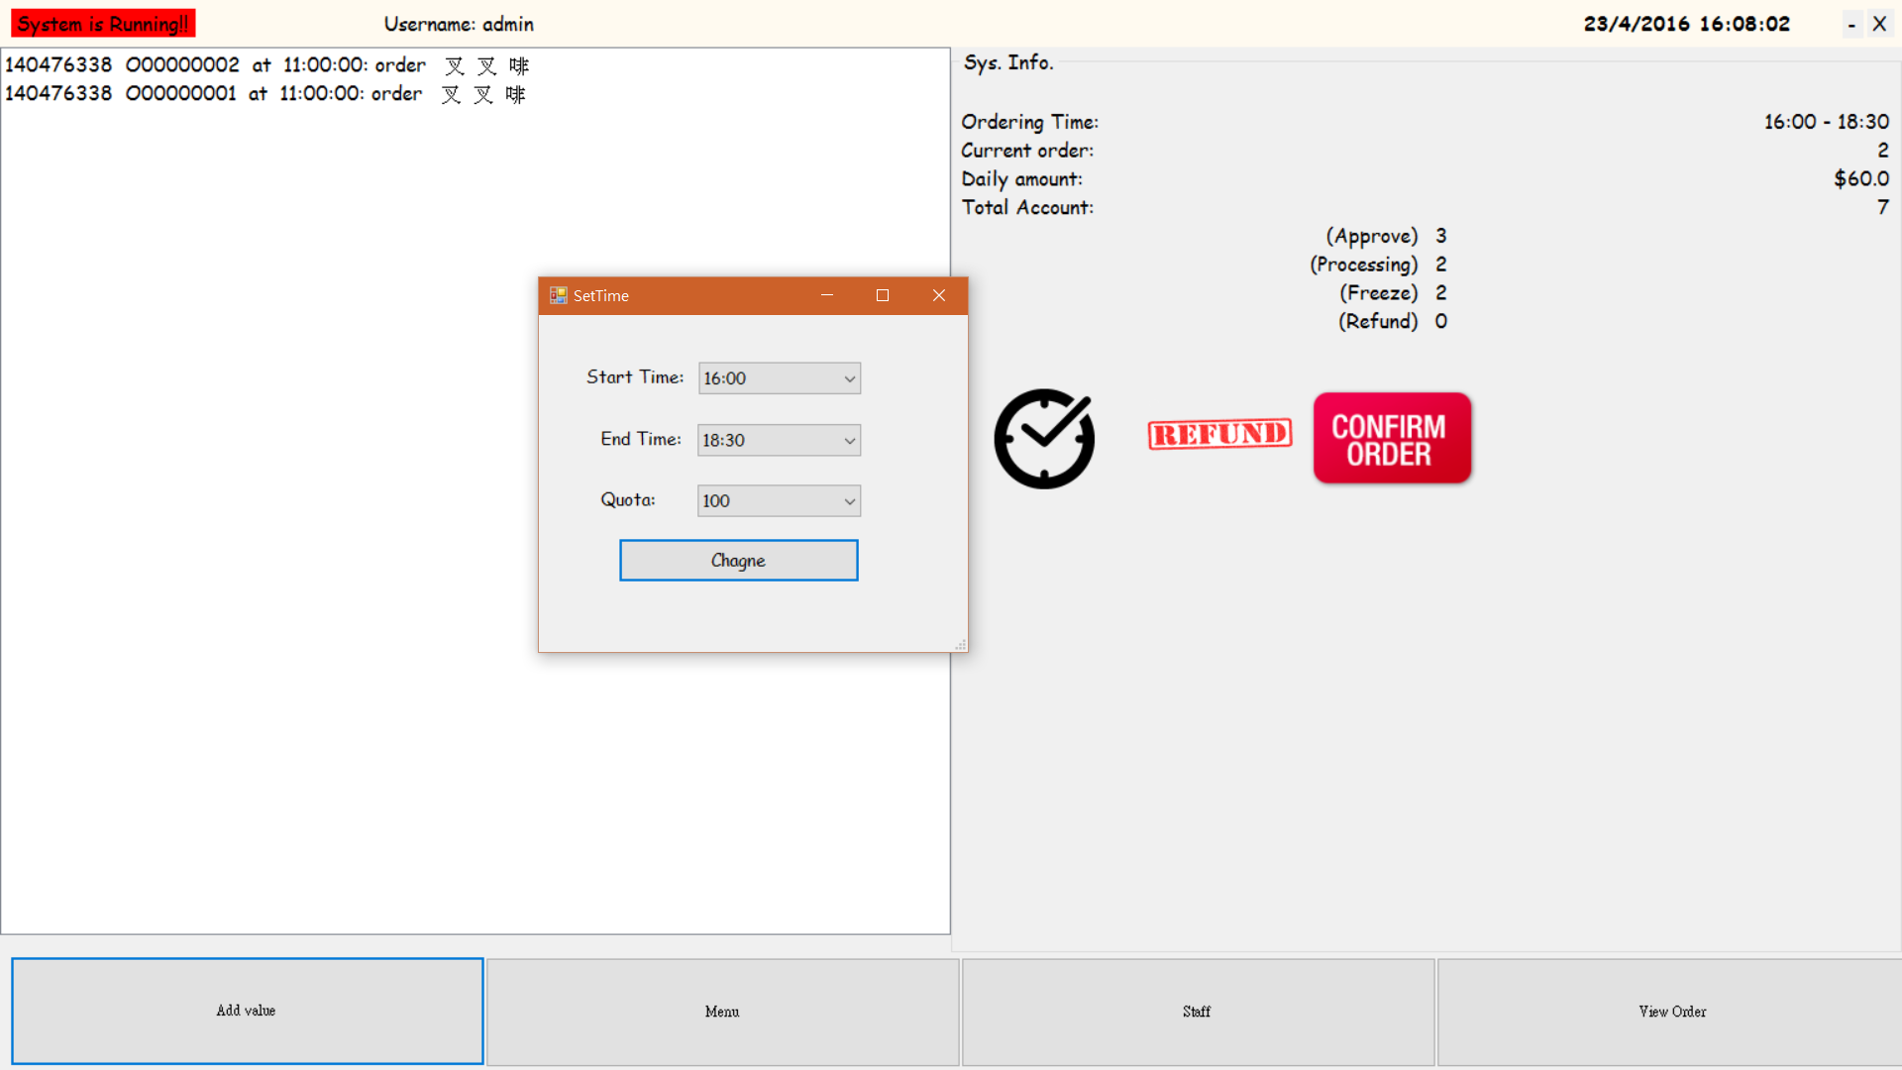 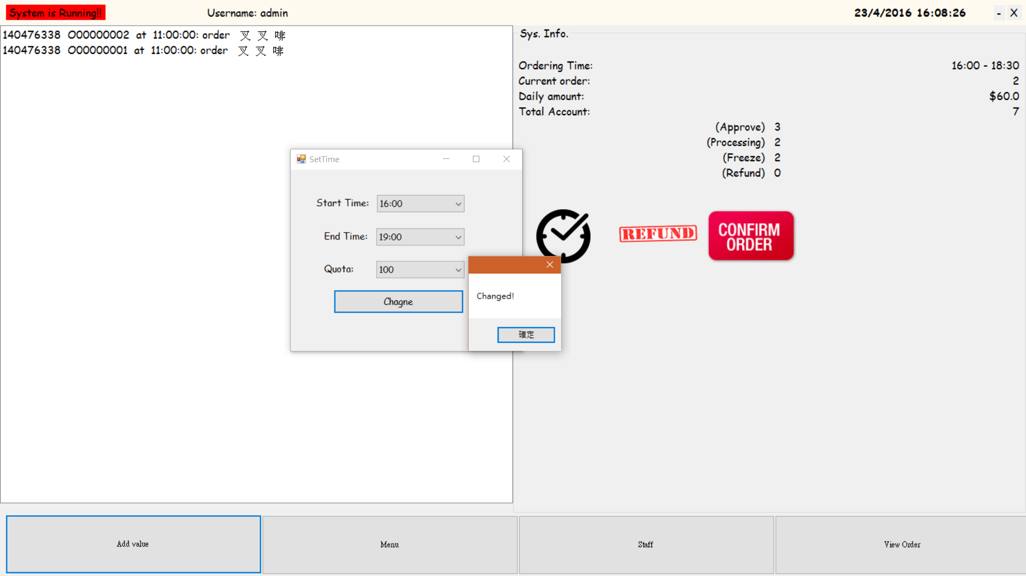

Staff confirm order

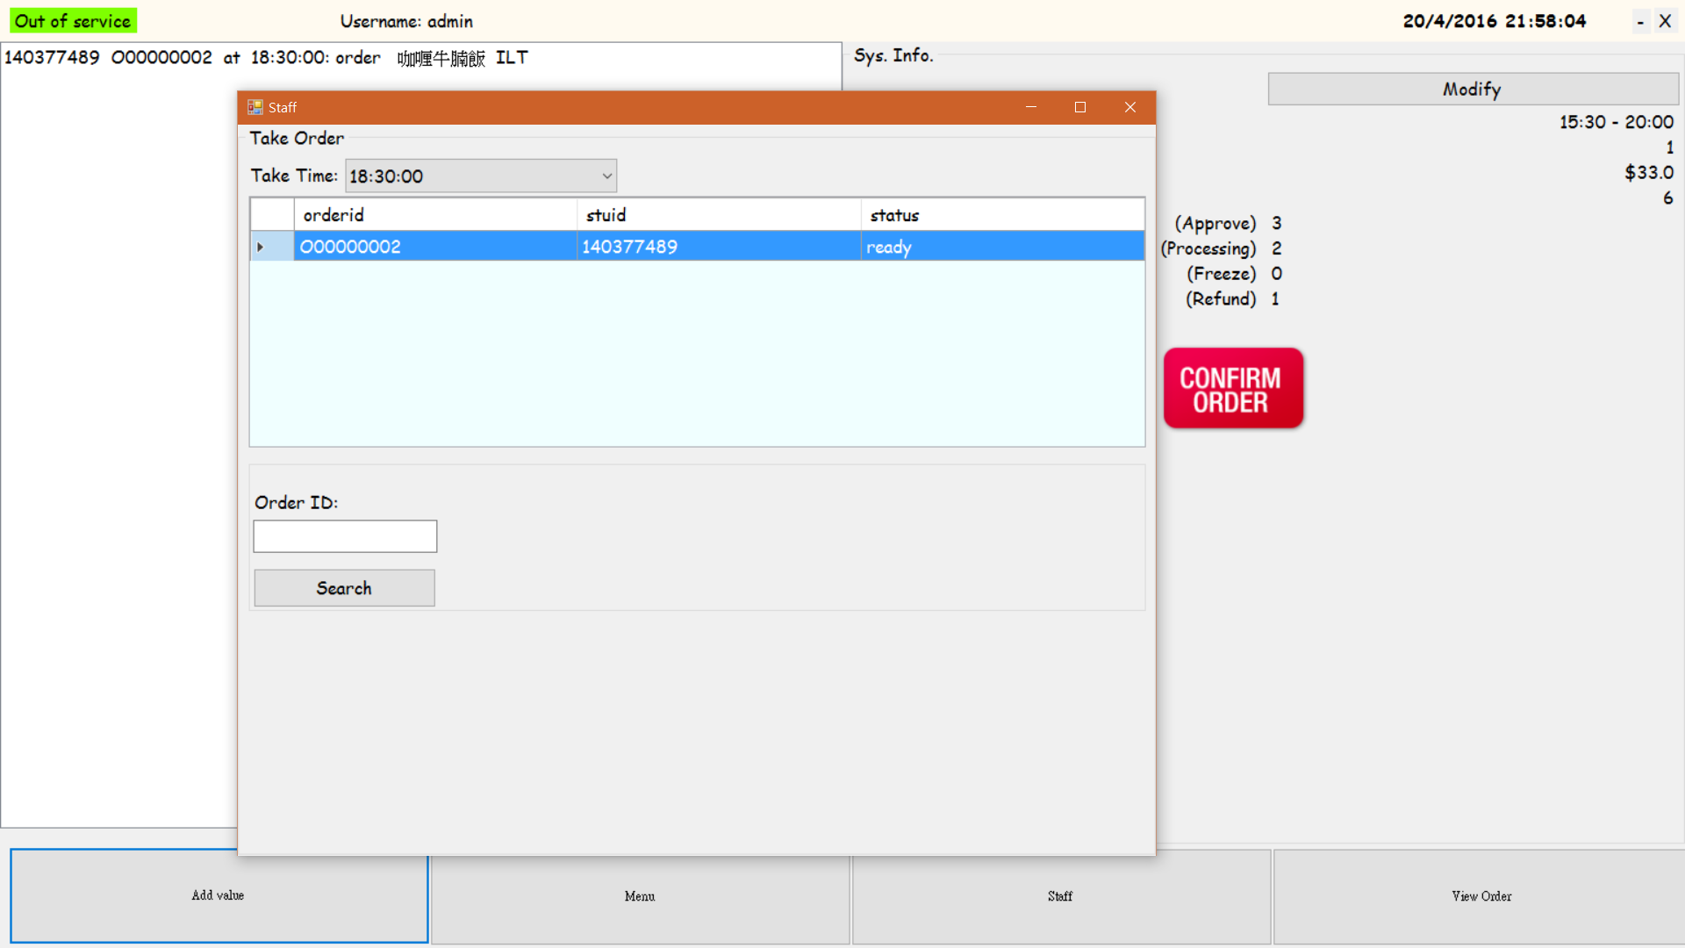

For checking order

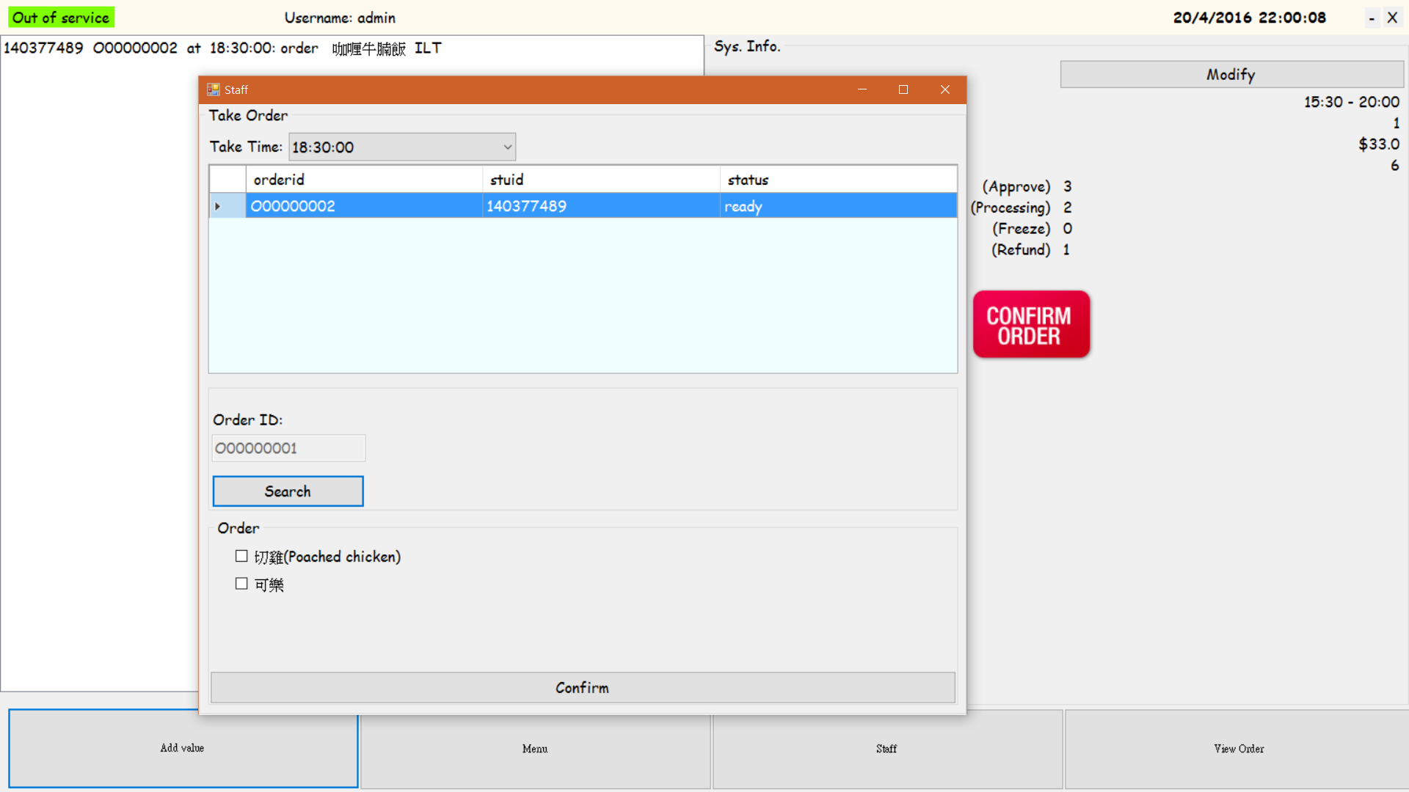

For confirm order

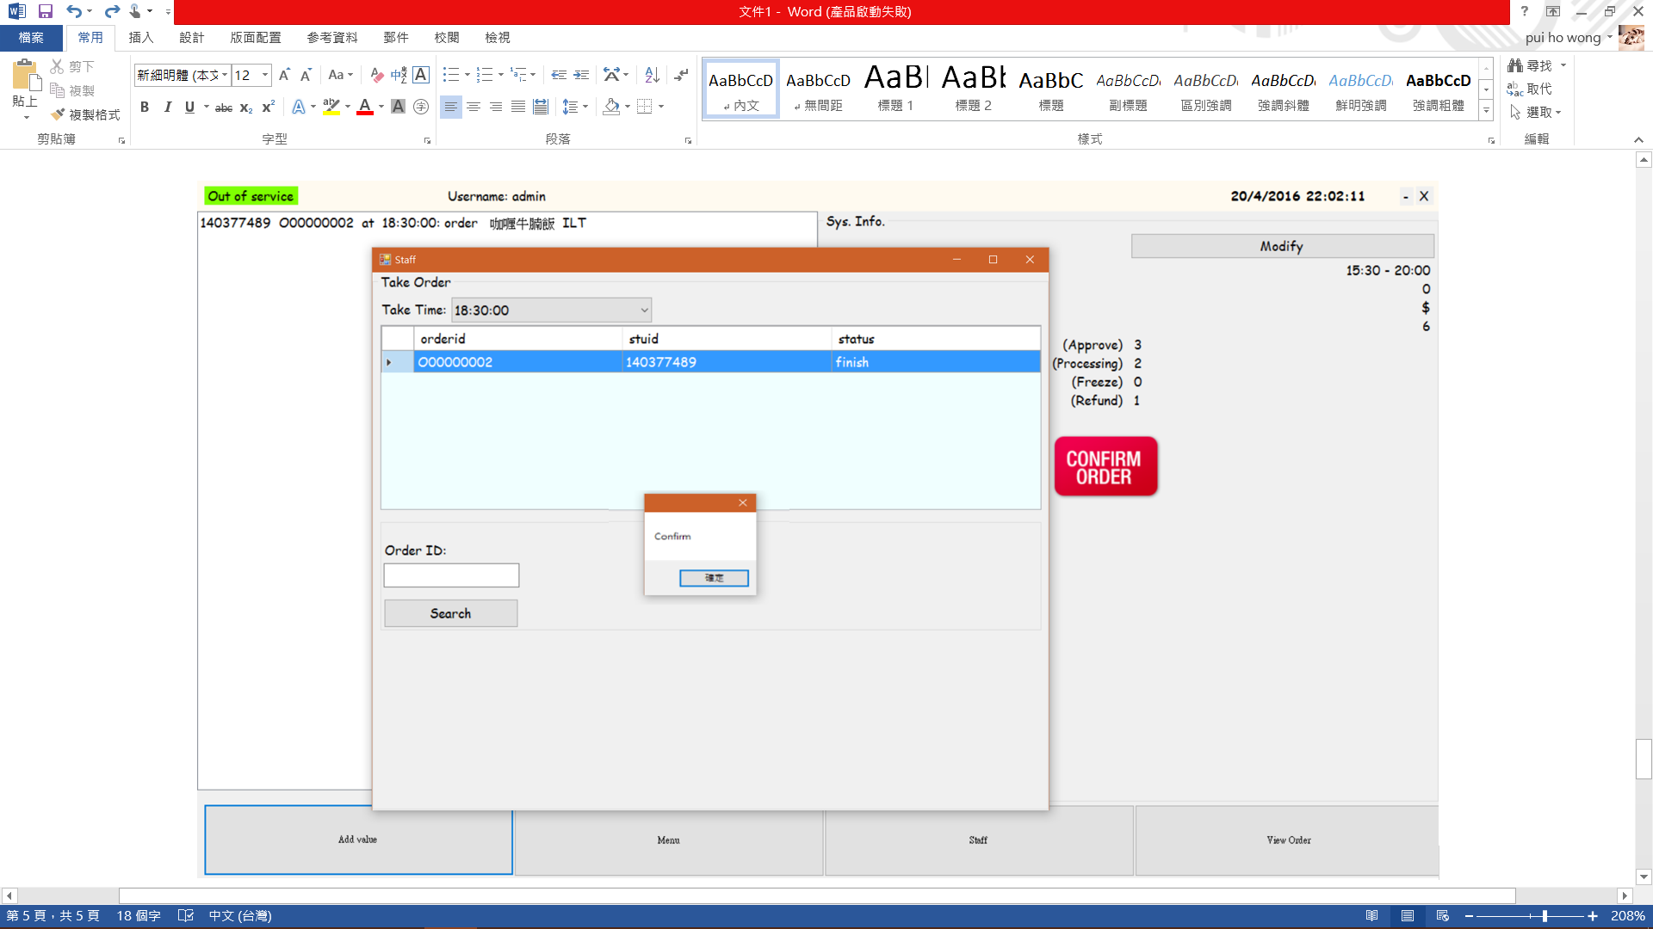

Add Value

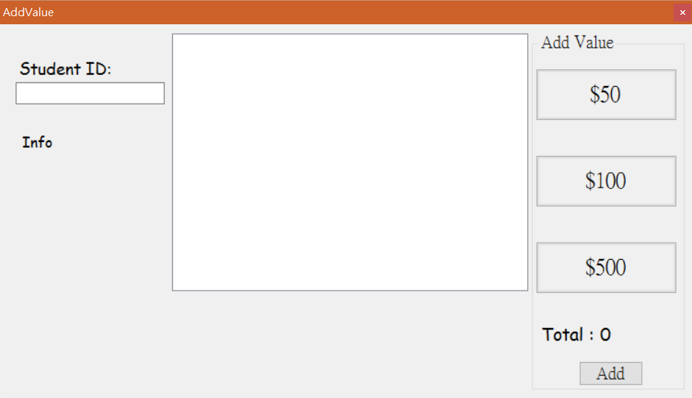

Input: 140377489 (scan)

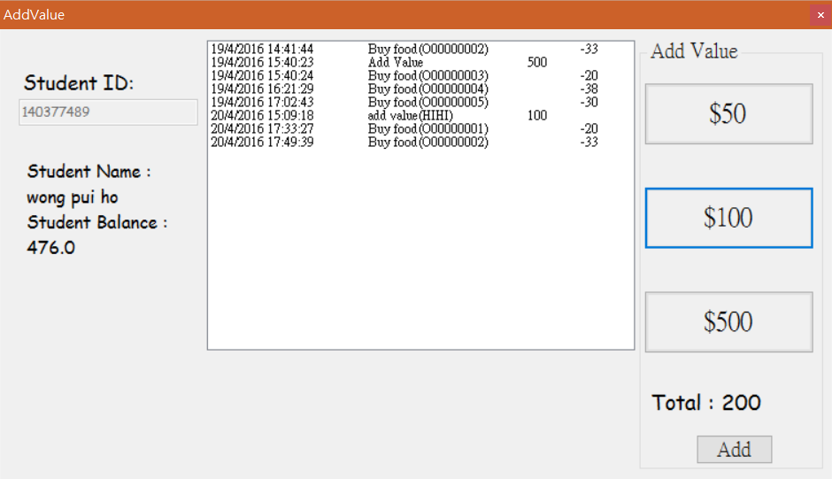

Click 2 times “$100” and click “add” to save

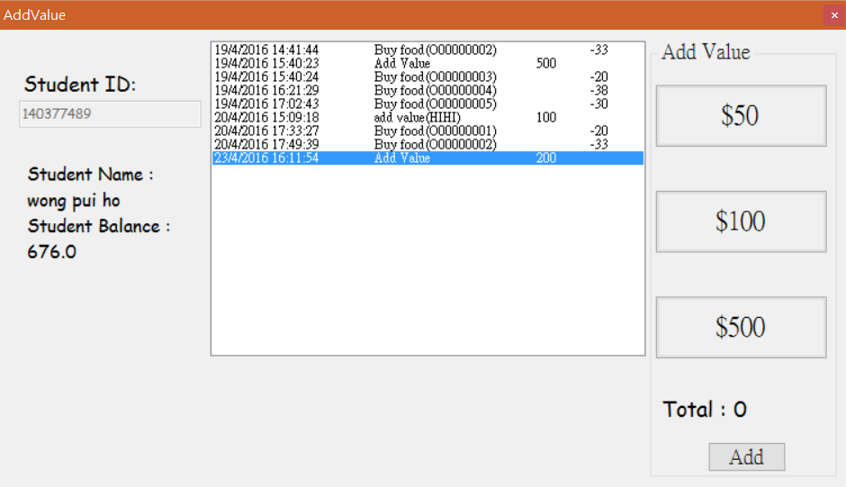

Record updated.

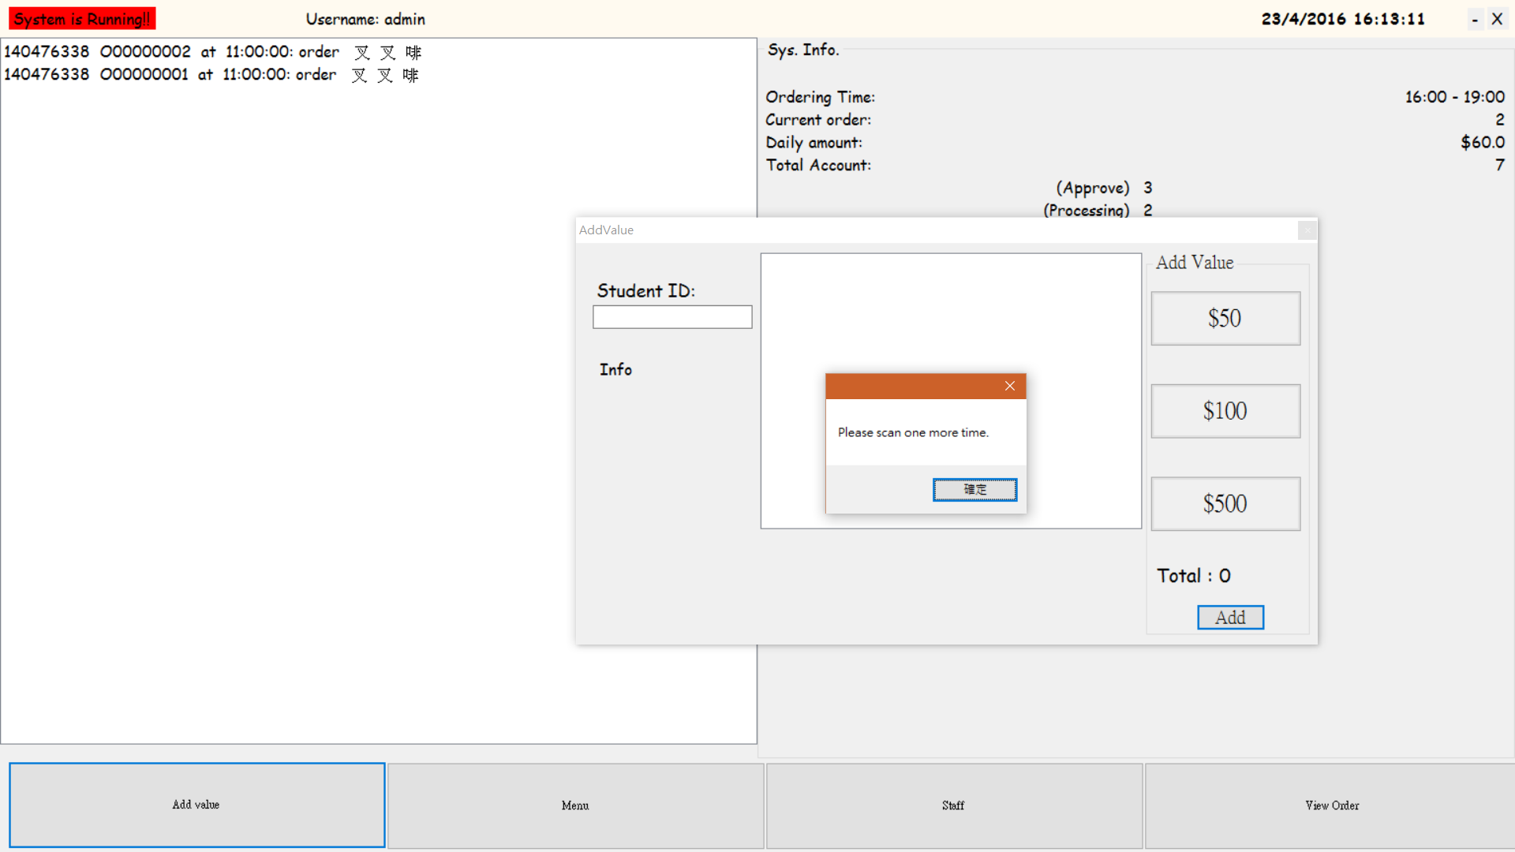

When do not input the student and click the “add” button

Menu

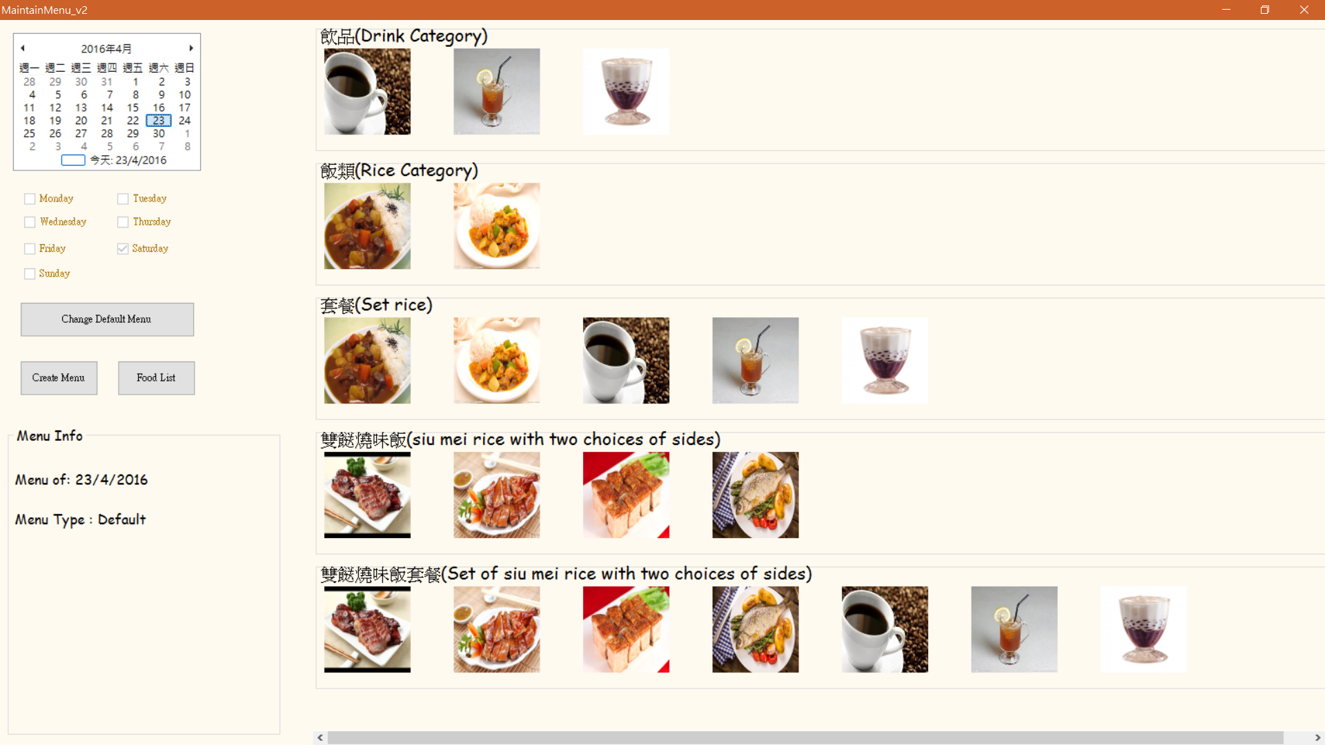

Select the date will display the menu of that date

Click “Create Menu”

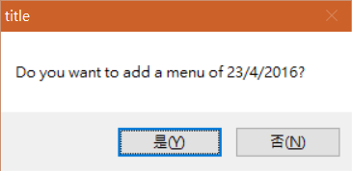

Click “Yes”, if click “No” select another date for creating menu.

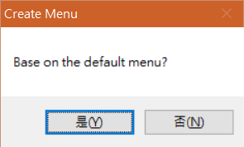

After that, Click “Yes” to create menu by default menu. If “No”, just choose the menu in the database.

Click “NO”

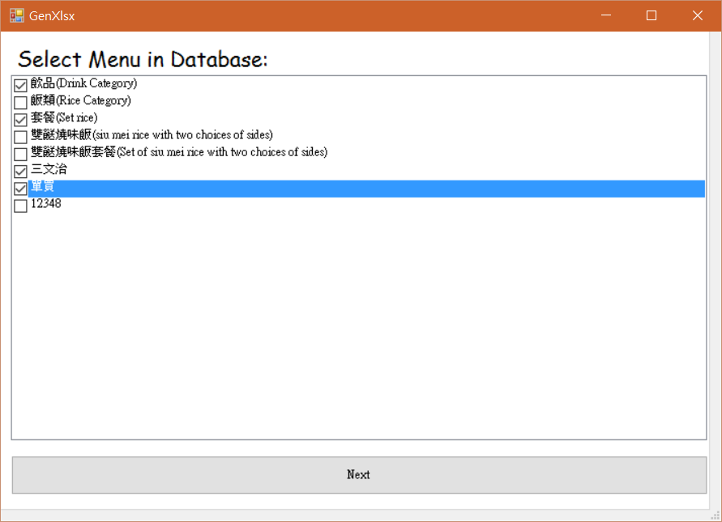

Select the menu which users wants after that match (drop) the food into the set of menu.

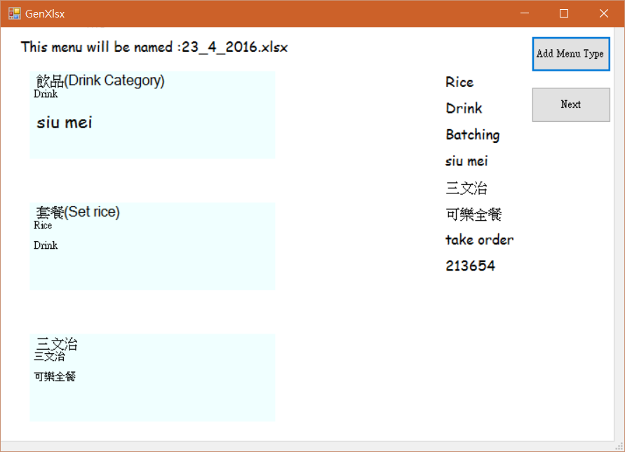

Click NEXT

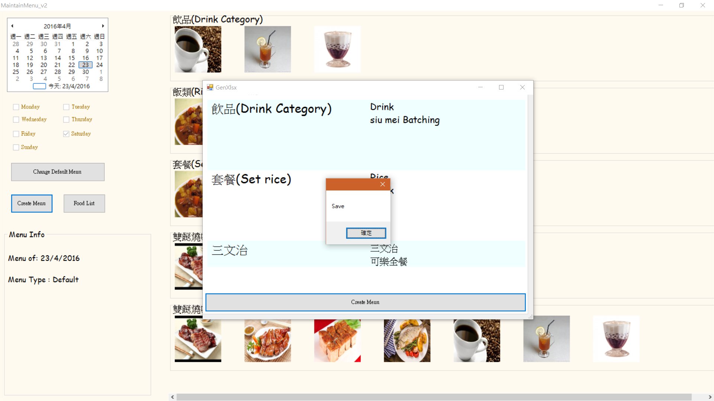

Click Create Menu to save.

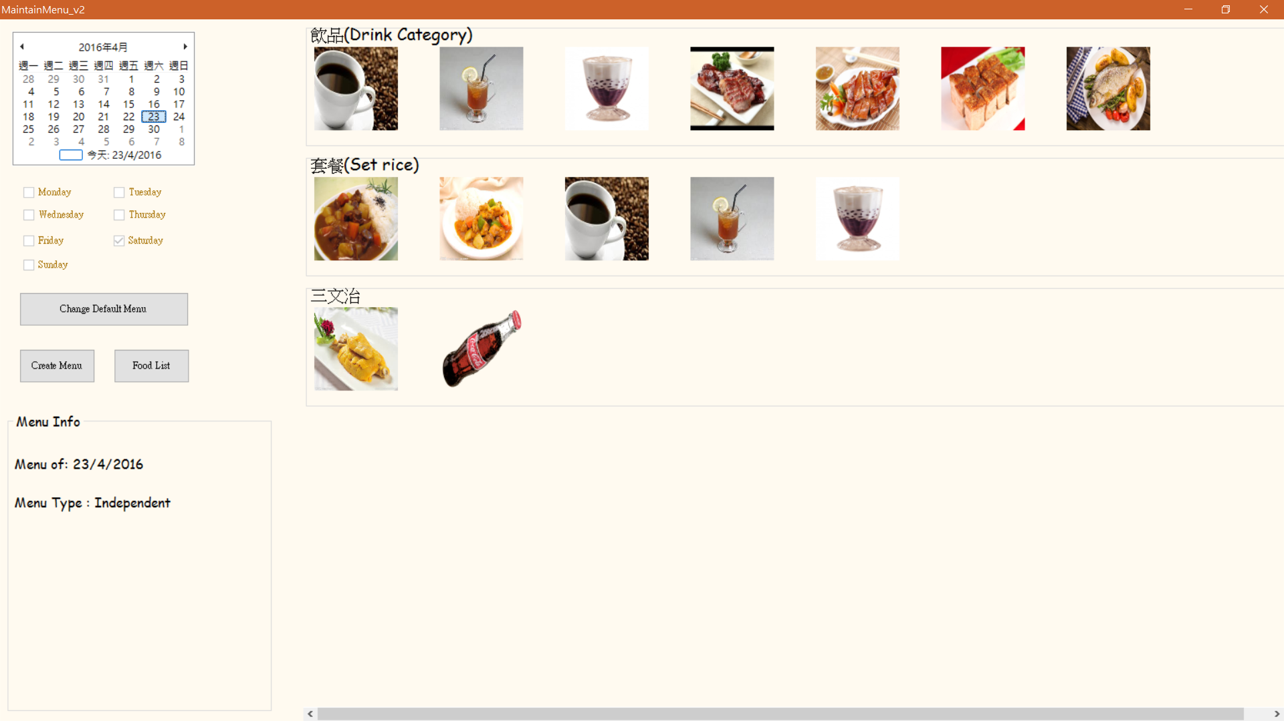

The menu is changed.

Click Food List

Add food 🡪 Click “add”

🡪input Name:公司三文治

ShortName : 公治

Price : 30 SPrice: 0

QTY: 100 DQTY :100

Food Type : 三文治 isShow : Y

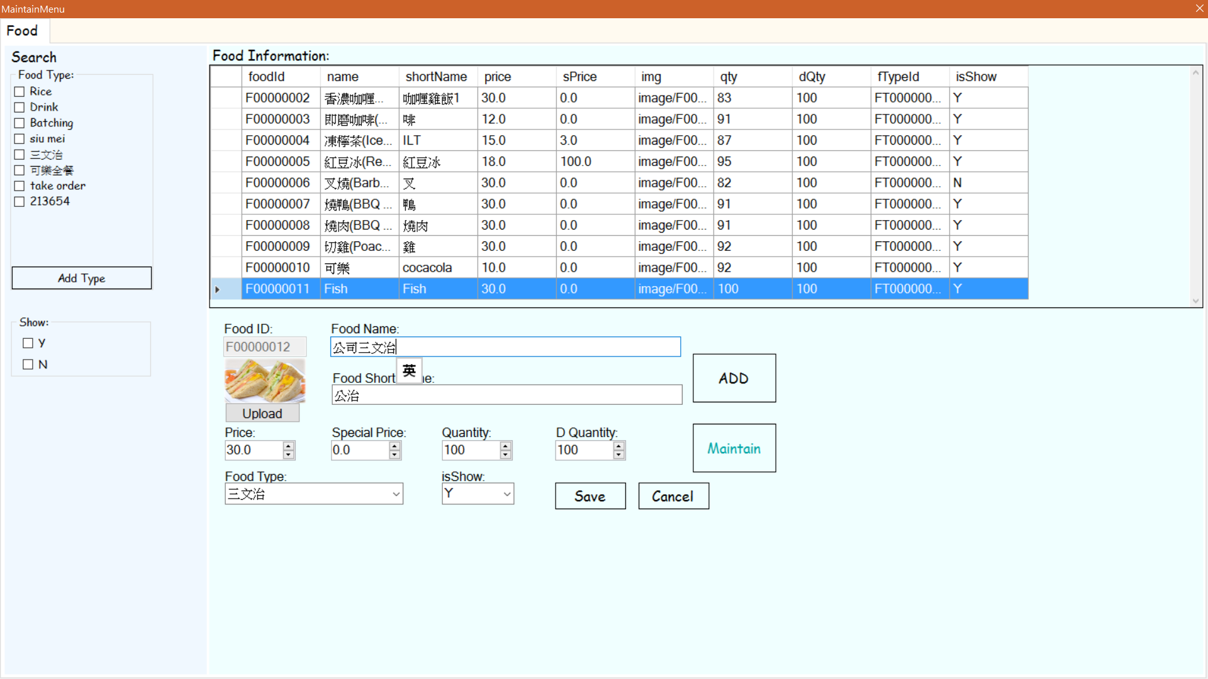

Click Update Can Upload photo.

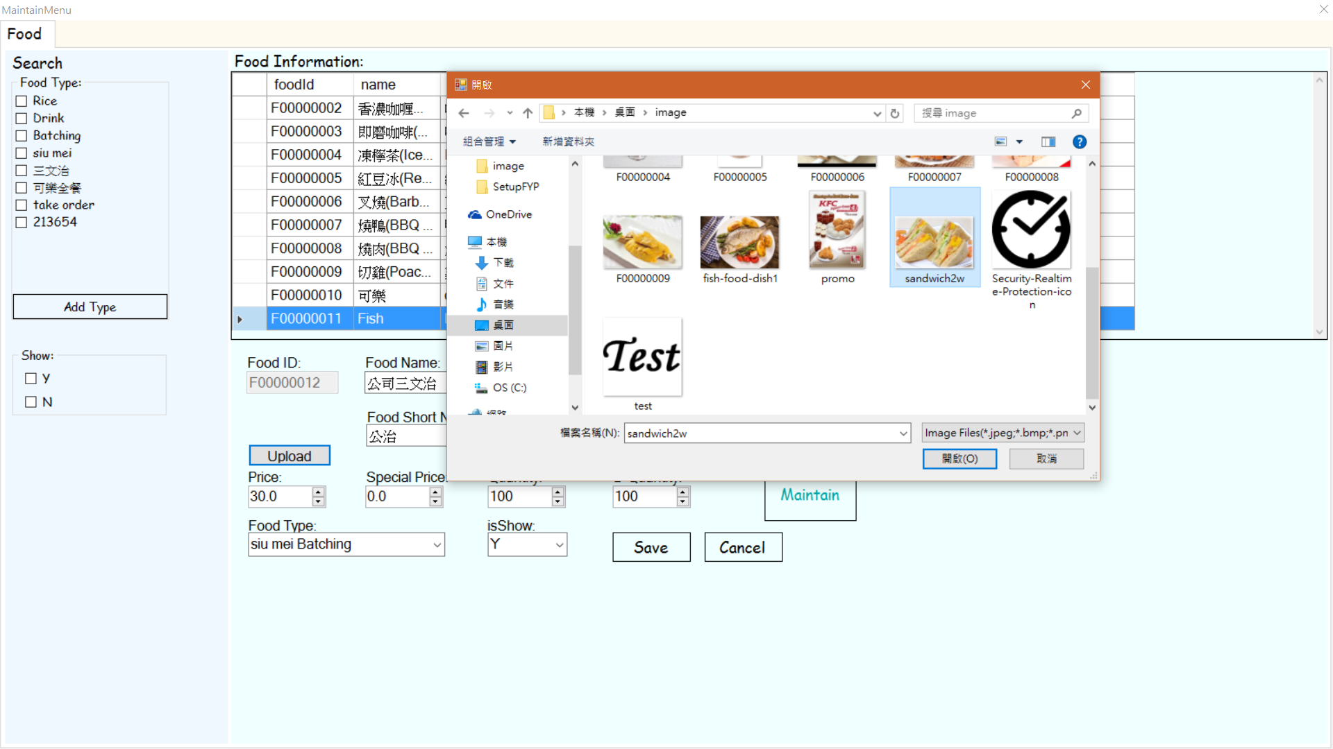

Click Save. The food is added.

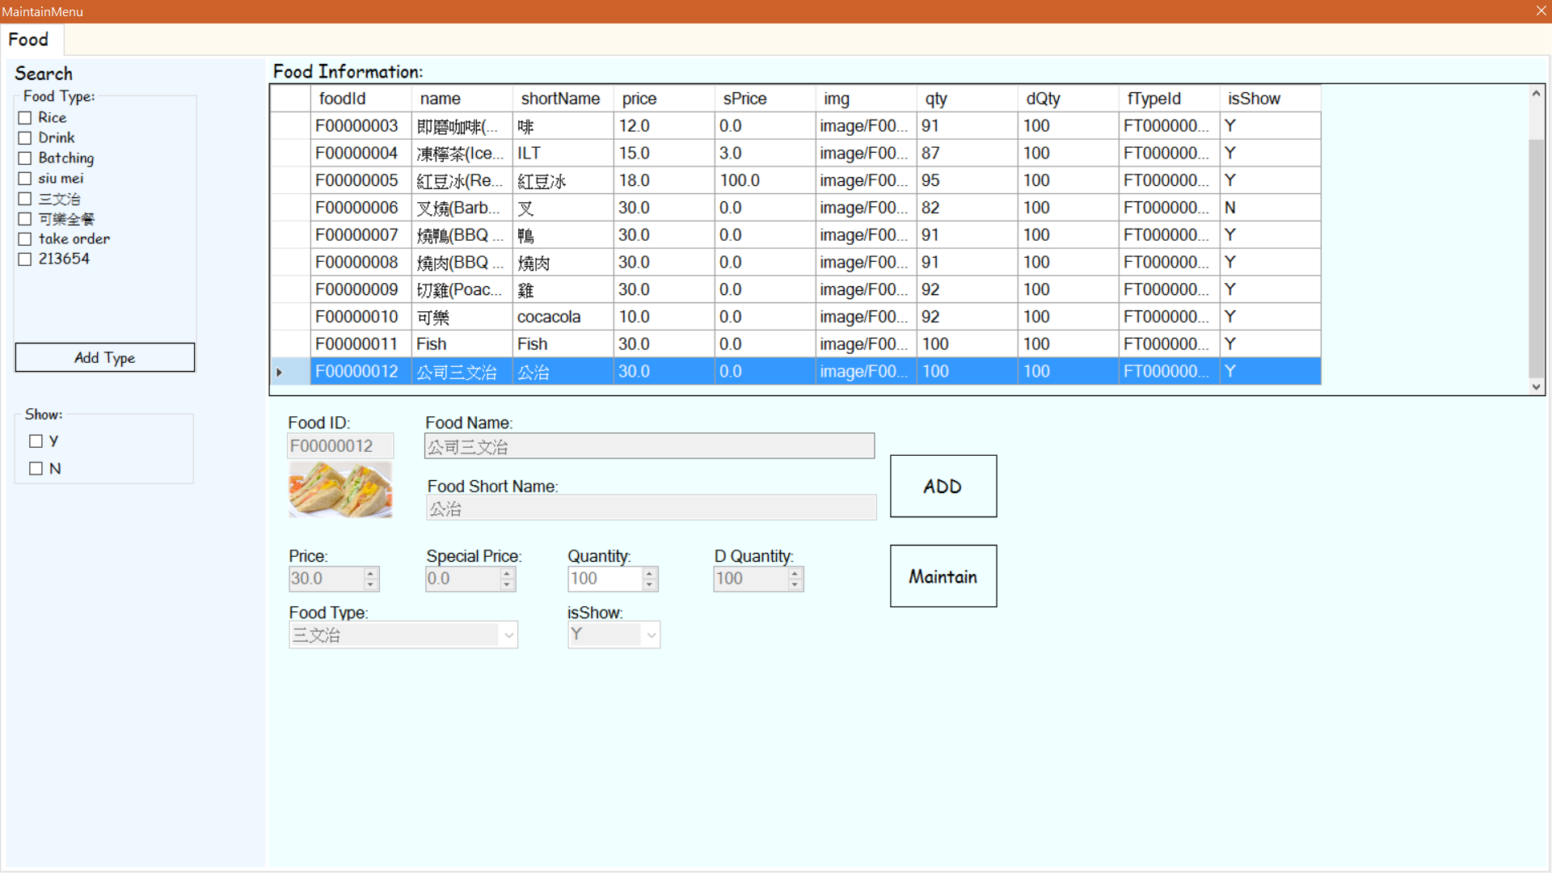

Maintain food 🡪Click “maintain”

🡪 change name : 魚肉三文治 ShortName : 魚治 Price : 15

Click “Change” to Change the price of food.

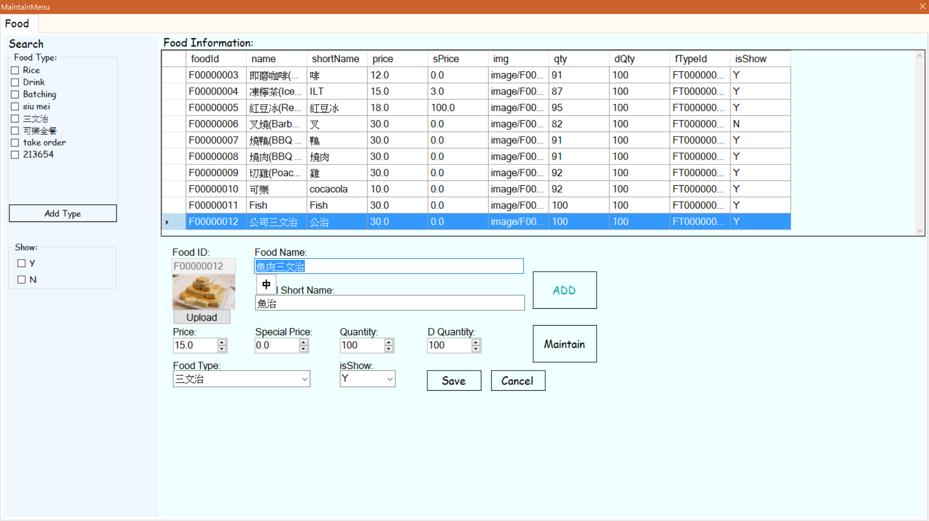

Click Save and the food is changed.